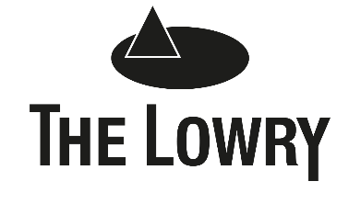

APPOINTMENT OF CONFERENCE & EVENTS SALES COORDINATOR

Thank you for your interest in the above post. Please find enclosed the job description and person specification for the Conference & Events Sales Coordinator vacancy.

To apply for this position, please email your CV and a covering letter (as a word document) to recruitment@thelowry.com. Your covering letter should include the following information:
- How you meet the requirements of the job description and person specification
- How you will apply your knowledge, experience, skills and qualities to fulfil the main duties and responsibilities of the post within a high profile visual and performing arts facility.

The application deadline for this vacancy is Wednesday 10 November at 10:00am.

Interviews will take place on Wednesday 17 November 2021.

Please be advised that The Lowry holds recruitment paperwork and interview notes for unsuccessful candidates for 6 months, which will be stored in a secure manner. After the 6 month period, all data will be securely destroyed. If you require any further information please refer to The Lowry’s Privacy Policy which can be found on The Lowry’s website.

Thank you again for your interest in The Lowry.

Yours faithfully,

Kelly Johnson
HR Administrator
recruitment@thelowry.com
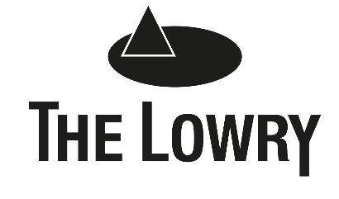

JOB DETAILS
Title: Conference & Events Sales Coordinator

Department: Hospitality

Reports to: Corporate Sales Manager

JOB PURPOSE

To maximise the revenue from the use of The Lowry’s conference and events facilities through the sale and co-ordination of conferences and events, including Christmas parties, weddings and other special events, in close liaison with the Corporate Sales Manager and all relevant departments.

MAIN DUTIES AND RESPONSIBILITIES

- Provide information on The Lowry’s facilities and services to potential and existing customers and accurately identify their needs, in line with the Lowry’s SOPs.
- As part of the team, respond to all enquiries in a timely fashion, taking necessary follow up action to convert the enquiry, reporting detail accordingly, diary management and housekeeping of the computerised booking system (Artifax) and databases.
- Complete administrative duties, including but not limited to, creation & recording of client files, information & contracts, creation of event details, invoicing of events and relevant reporting.

- Create bookings within Artifax and ensure these bookings are updated with all relevant details as information develops. Liaise with internal departments ensuring effective communication.

- Conduct both sales and logistic site visits with customers and attend relevant meetings. Contact the client pre-event to co-ordinate and arrange final details, and amendments.

- Work with the Event Delivery Managers to ensure they have accurate and up to date information regarding the set-up and operation of each event, assisting with the operation and on occasion covering this role.

- Assist with the co-ordination of internal room bookings & events.

- Undertake proactive sales calls and emails daily to existing customers, lapsed customers and prospective clients to generate business leads and bookings. Supporting any sales and marketing activities, including attendance at internally & externally hosted events or exhibitions.

- Work together with other departments within The Lowry ensuring the best possible experience for all our visitors and customers.

- Undertake any other reasonable duties, commensurate with the level of the post so as to ensure the smooth running of The Lowry.

- Promote and comply with legislation and The Lowry’s policies on equal opportunities and health and safety both in the delivery of services and the treatment of others.

- Identify and undertake training and development as required in order to meet personal and business needs.

REVIEW ARRANGEMENTS

This job information cannot be all encompassing. It is inevitable over time that the emphasis of the job will change without changing the general character of the job or the level of duties and responsibilities entailed. Consequently, this information will be periodically reviewed, revised and updated in consultation with the post holder to reflect appropriate changes.

CRITERIA | ESSENTIAL | DESIRABLE
SKILLS / ABILITIES | Excellent communication and interpersonal skills, with the ability to relate with a wide cross section of people; external clients and suppliers and internal colleagues and departments  A commitment to excellent customer care.  Excellent organisational and time management skills, accuracy and attention to detail  Have an engaging personality and a desire to be part of a dynamic sales culture | Demonstrate the ability to solve problems quickly and creatively, working under own initiative
KNOWLEDGE |  | An active interest in event and hospitality trends and innovations
QUALIFICATIONS, TRAINING AND EDUCATION |  | Event or Hospitality qualification
EXPERIENCE | Hospitality sales/co-ordination experience, or previous experience in a similar role  Customer service experience
OTHER REQUIREMENTS | Computer literate including Microsoft Office  An understanding and empathy of The Lowry’s core functions  A flexible and adaptable approach to fulfilling the duties of the post | Knowledge of Artifax Event

