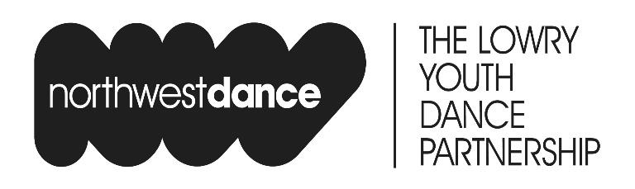

How to Apply for The Lowry Centre for Advanced Training in Dance [CAT]

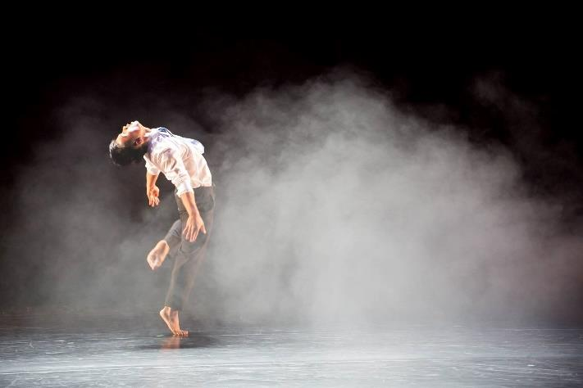

We are recruiting for Autumn 2021 entry, adapting our audition process in alignment with current covid regulations. We are hosting our CAT Audition on Sunday June 27th 2021

There are lots of ways to find out more about The Lowry CAT programme before you apply via our series of events. See below for more details about our upcoming programme and application information.

All sessions are open to young people aged 11-16 (on 1 Sept 21) and are free to attend but must be booked in advance.

Any general queries visit our useful FAQs on The Lowry CAT webpage or email CAT@thelowry.com

The Lowry CAT is part of the National Dance CATs funded by the Department for Educations Music and Dance Scheme.

Open Days:

It is highly advised that those wishing to apply for CAT, attend an Open Day prior to auditioning. Open Days give young people the opportunity to experience an insight into The Lowry CAT’s prevocational training programme. The days will include a fun and challenging technical and creative workshop delivered by our highly accomplished tutors and a chance for students, parents & guardians to find out more about the dance opportunities available to them at the Q&A session.

You can book onto one of our Open Days online or via The Lowry Box Office on 0843 208 6000

Application forms for the CAT Audition Day will be made available at Open Days and on The Lowry CAT web page.

Sunday 6th June 21
09:30-13:45 (Afternoon sessions may become available if we reach capacity)
The Lowry, Salford Quays | Greater Manchester |

Sunday 12th June 21
09:30-13:00
Newbiggin Hall | Carlisle | Cumbria

12:00-17:00 (precise times to be confirmed after booking)
The Brewery Arts Centre | Kendal | Cumbria

Friday 18th June 21
16:45-18:45
Online via Zoom

Sunday 20th June 21
09:30-13:45 (Afternoon sessions may become available if we reach capacity)
The Lowry, Salford Quays | Greater Manchester |

CAT Open Classes / Audition Preparation Sessions

An opportunity to improve your contemporary dance technique and prepare for the audition with support from a Lowry CAT tutor.

Sign up here: https://tinyurl.com/vavmpect

Fridays 7th May – 25th June 21
16:45-17:45
Online classes via Zoom

Online Taster Workshops

Special online events giving an insight into the specifics of Lowry CAT training.

Follow our facebook page @nwdancethelowry to get updates on how to sign up. Alternatively register interest via CAT@thelowry.com

What Is A Dance Career?
Sunday 30th May 21
10:00-13:00

The Lowry CAT Audition

Audition via Application Only. All applicants should ideally attend an Open Day in advance of the Audition, at which Application Forms will be made available. Application forms can also be found on The Lowry CAT web page.

Sun 27th June 21
0900 – 1800 approx. Time TBC
The Lowry, Salford Quays | Greater Manchester

Auditions can be a very tense and nerve wracking experience, even for the most seasoned of professional dancers. It is, therefore, important to recognise that your decision to attend already demonstrates a strong sense of self-motivation and commitment. Please be advised that the audition process is devised in order to assess potential, ability, commitment and enthusiasm rather than technical excellence. The creative and choreographic elements of the audition will give you an opportunity to demonstrate this potential and it is important to note that every effort will be made to create a safe and relaxed environment in order that you can work to your maximum potential.

Even attending an audition is a valuable learning experience and in many ways will benefit future applications that you make. We would ask therefore that you try, even though it is sometimes difficult to do so; to approach the audition as though you would any other workshop and enjoy the process of the day!

